

DAU Curriculum Management Maintenance Plan
Provided by Enspire Learning to support the DAU Curriculum Management eLearning Course
Table of Contents
1.0 File Types and Native Programming 3
2.0 Course Structure and Map Overview 3
3.0 Instructions for Editing Files 4
3.1 Graphical User Interface (GUI) 4
3.2 Caption Text 5
3.3 On-screen Text 6
3.4 On-screen Photos. 8
3.5 Interactivities 9
3.5.1 Arguments Used in the Course 10
3.6 Audio 11
3.7 Resources 11
4.0 Inventory of Files 11

1.0 File Types and Native Programming

Media Asset | Source File Type | Native Program
PNG, JPG, GIF | PSD, PNG, RAW | Adobe® Photoshop® software
SWF | FLA | Adobe® Flash® platform
FLV | MOV | Apple ® Final Cut Pro® software
SWF | MP3 | Apple® Logic Studio® software, Digidesign® Pro Tools® software, Sony® Sound Forge® software
HTML |  | Apple® Xcode® developer suite
XML |  | Apple® Xcode® developer suite

2.0 Course Structure and Map Overview

Each module is launched by index.html. The index file has an Adobe® Flash® Player detector and will load the scoIndex.html file. The scoIndex contains the Adobe Flash Player object.

Course content is contained in the full-struct.xml. This includes text found in the narration boxes, text in the media area, and text in the menu items. Labels for interactive areas of the course, such as text on the GUI or on the multiple-choice quizzes, are located in the labels.xml document inside the xmls folder. The full-struct.xml also contains code arguments (args) that control segment order, template functionality, and interactivity functionality.

Audio is pulled in dynamically from .SWFs in the audio-wrap folder located in the root module folder.

Visual course content is contained in c1.swf files in the clips/chap1/sect1 folder. The source FLA file contains movie clips that are labeled on the timeline with a name corresponding to segment names within the full-struct.xml. Interactive segment templates exist in the interactivity.swf file, and re-used templated segments such as bullet lists exist in the template.swf. The former exists in the "interactivity" folder and the latter in the "base" folder.

Interface assets and functionality are found within the base.fla working file in the "base" folder. This file contains navigation elements such as the segment-to-segment control buttons, as well as the menu functionality and layout, narration text fields, resource text fields, and title text fields. The course .SWFs are pulled into a movie clip sitting on the stage in the base. In-course preloaders also live here.

The "classes" folder contains several ActionScript (.as) files containing many of the hidden elements controlling the course. The classes set up within the .as files define button actions, build menus, describe how the course should function, and help the full-struct.xml talk to the various Adobe Flash files.

All of these elements are pulled together by the Interactive Learning Environment (ILE). The textual content within the XMLs, the audio SWFs, and the visual animations and assets contained within the SWF files are all pulled in dynamically when the ile.swf is launched, with the classes and code within the .as files describing how they interact with each other. The course preloader is within the ile.fla working file and can be edited there. The various html files all pull into the ile.swf.

3.0 Instructions for Editing Files

This section provides an overview on how to modify specific elements of the course content files and interface.

3.1 Graphical User Interface (GUI)
The Graphical User Interface is stored in the base.fla within the “base” folder in the root module folder. The base file comprises the design layout of the course and contains movie clips that dynamically bring in the narration and visual media (from the .swfs) and holds the design for the menu and any other panels such as “resources.” Each of these elements live in their own movie clips and can be reskinned by entering the movie clip in question and changing graphics or colors. Buttons can be changed the same way, by going into the button’s timeline and editing elements there.
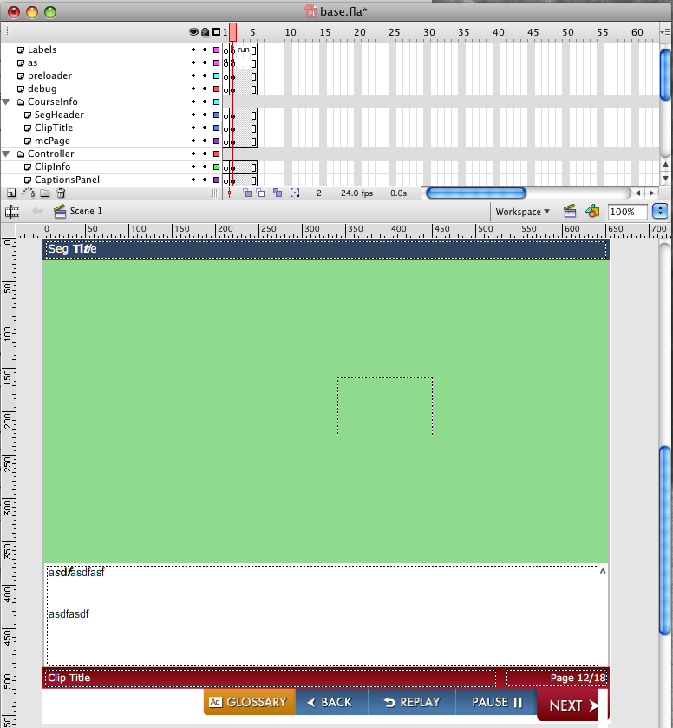
Base.fla shown.

3.2 Caption Text
Caption or narration text is changed within the full-struct.xml. This string exists within the XML ID “text.” Be careful when editing the .xml as deleting XML “artifacts” (the XML code that indicates what area the content within the full-struct.xml should be pulled into) may break the course. For example, if a “>” is deleted from code that defines a particular string id, the course will likely no longer show any content past that point. If narration text is changed in the full-struct.xml, the voiceover will no longer match.

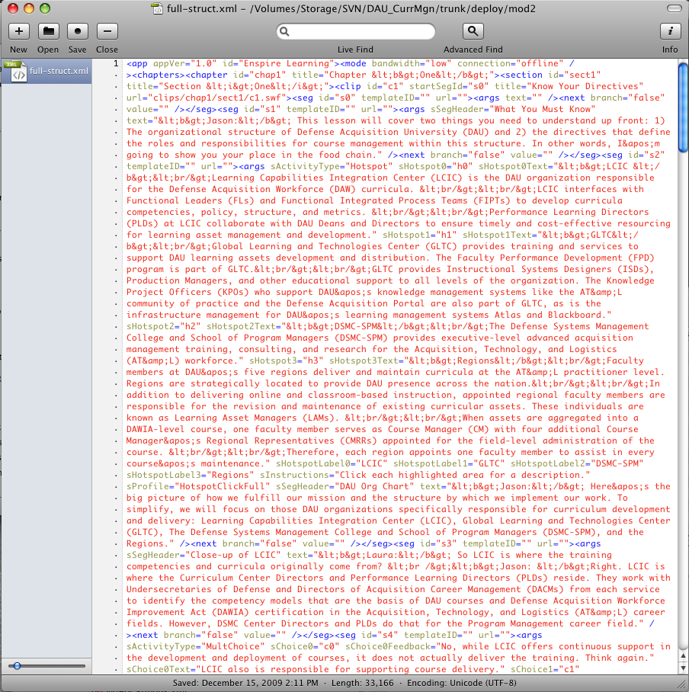
Full-struct.xml file for module 1 shown.

3.3 On-screen Text
Most of the on-screen text is handled with code arguments within the full-struct.xml. Arguments are a way to pass text variables from the XML file into specific text fields within the media area. A chart, for example, may have several dynamic text fields. Often, these text fields will be given instance names such as “mcText.”

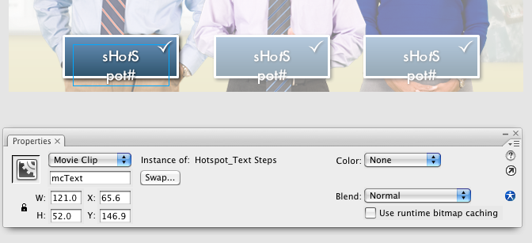
Instance name “mcText” shown in the Flash Properties window.

These text fields are then instructed to pull that segment’s “sText” from the args. The course will search the full-struct.xml for the segment ID, and then look for the arg “sText.” Editing the values in these args will change what appears on screen. If the text is repeated often, it may be found in the labels.xml file within the “xmls” folder, as well. Interactivity text is handled in much the same way and is usually named in a descriptive fashion. For instance, the “sBranchText0” ID is linked to a branch title.

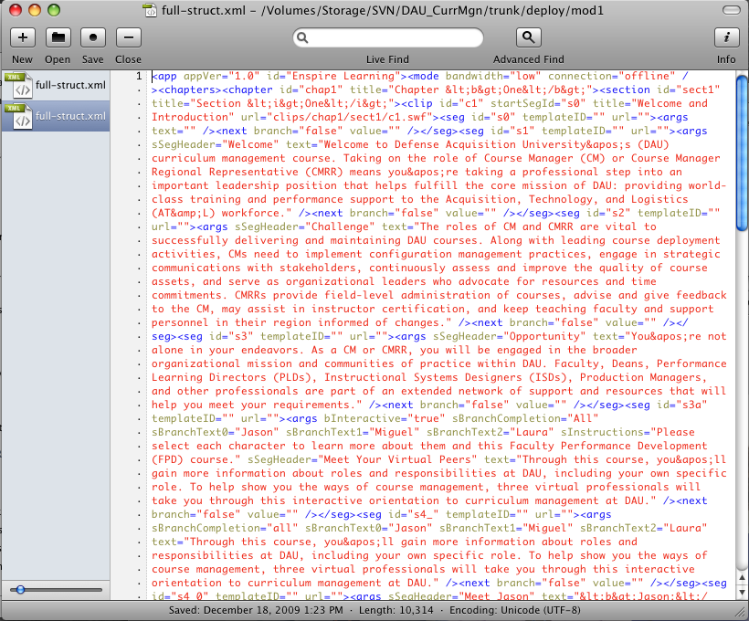

Full-struct.xml shown with args highlighted.

3.4 On-screen Photos
Media area images and animations can be found within the .fla files. The Adobe Flash files are set up so that each segment is contained within its own movie clip and labeled according to segment name on the main timeline.
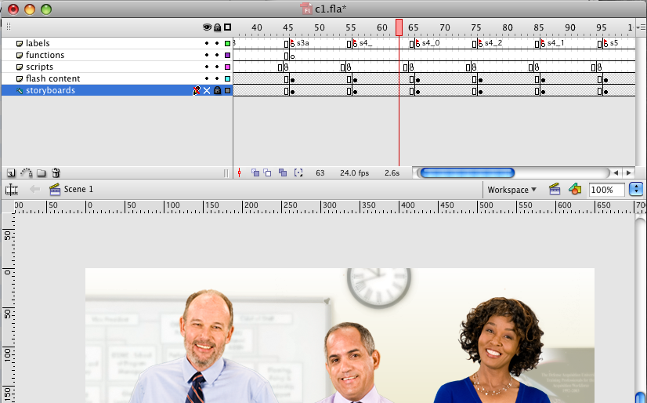

Timeline in Flash shown with Label s4_ as the segment ID.

This segment name label must correspond with the segment IDs within the full-struct in order to display.

Seg ID is shown as s4_ in full-struct.xml.

Some visual elements are created as vector illustrations in Adobe Flash and can be edited directly in the Adobe Flash working file. Other assets are brought in as raster images externally, like .jpgs and .pngs. They may need to be edited with graphics software such as Adobe ® Photoshop® software, and then imported into the .fla file.

3.5 Interactivities
Templates for interactivities can be found and edited within the interactivity.fla file within the “interactivity” folder located in the module root folder. Each template can be found on “guided out” layers in the main timeline or in the library. The individual elements of each template can be edited and re-skinned.

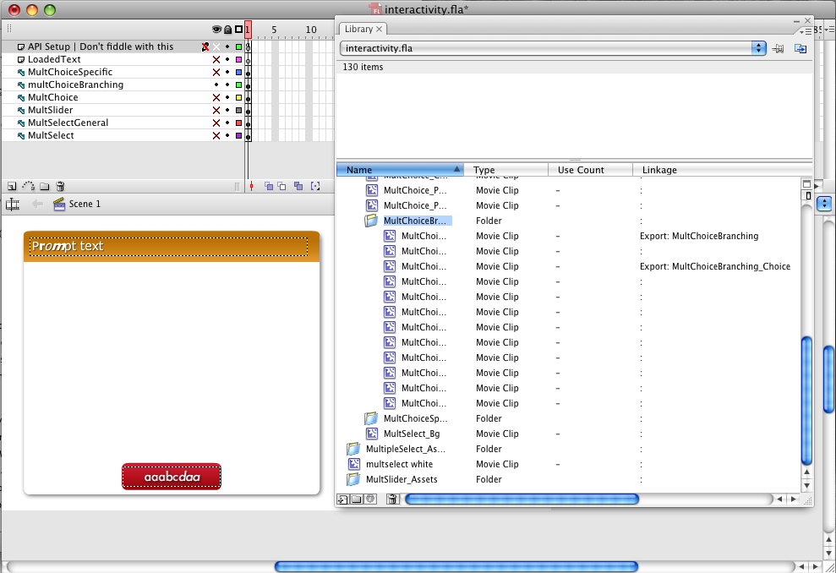

Interactivity.fla shown with MultChoiceBranching guided out in the timeline and shown in the library.

The content for the interactivities is populated dynamically through args in the full-struct.xml.

3.5.1 Arguments Used in the Course

Code arguments | Description
sSegHeader | Title of segment
sInstructions | Instructions that display on a banner
sBranchText0 | Title of a branch
bForceAdvance | Forces segment to advance when auto-advance is not on
noAudio | Turns audio off
sBackSeg | Assigns a specific segment to the back button
sBullet0 | Text in a bullet
sTemplate | Template for activity assigned in config.xml
nBulletSpacing | Spacing between bullets
nBulletDelay | Timing for bullets to appear onscreen
sActivityType | Type of activity
sPrompt | Text for activity question
sChoice0 | Text for activity choice
sChoice0Text | Matching text for activity answer
sChoice0NextSeg | Assigns a segment for the choice
sProfile | Profile for type of template assigned in configs.xml
nChoiceSpacing | Spacing between choices
sBranchCompletion | How many branched segments until completion
sText0 | Text on screen
sHotspotLabel0 | Text on hotspot
sHotspot0 | Assigns correct match to hotspot
sHotspot0Text | Text for matching hotspot
sChoice0Feedback | Specific answer feedback
sLastFeedback | Last feedback given for quiz question
sIncorrectFeedback | General incorrect feedback
sCorrectFeedback | General correct feedback
sResource0Label | Text label on screen
sResource0 | Location of resource to launch

3.6 Audio
Audio narration and voice over can be found in the “audio” folder in the root module folder. Audio files will be named according to module, clip, and segment. Keep in mind, if narration content is changed, these audio files will need to be updated to match (and vice versa).

3.7 Resources
Resources are held in the "resources" folder within the root module folder. This usually takes the form of a .pdf file, called in by the resources.xml file found within the "xmls" folder, also in the root module folder. Resources can be easily added by adding a new string with the same format as the existing string and changing the path. The path must point directly at the new resource file within the resource folder. Relative paths may be used. Note that the path is case-sensitive, so accuracy is required when naming the xml string and the file.

4.0 Inventory of Files
Module 1
path | file | type | description
001/audio | sect1_c1_s0.swf | Audio file
001/audio | sect1_c1_s1.swf | Audio file
001/audio | sect1_c1_s2.swf | Audio file
001/audio | sect1_c1_s3.swf | Audio file
001/audio | sect1_c1_s3a.swf | Audio file
001/audio | sect1_c1_s4_.swf | Audio file
001/audio | sect1_c1_s4_0.swf | Audio file
001/audio | sect1_c1_s4_1.swf | Audio file
001/audio | sect1_c1_s4_2.swf | Audio file
001/audio | sect1_c1_s5.swf | Audio file
001/audio | sect1_c1_s5a.swf | Audio file
001/audio | sect1_c1_s6.swf | Audio file
001/audio | sect1_c1_s7_.swf | Audio file
001/audio | sect1_c1_s7_0.swf | Audio file
001/audio | sect1_c1_s7_1.swf | Audio file
001/audio | sect1_c1_s7_2.swf | Audio file
001/audio | sect1_c1_s7_3.swf | Audio file
001/audio | sect1_c1_s8.swf | Audio file
001/audio-wrap | sect1_c1_s0.swf | Audio file
001/audio-wrap | sect1_c1_s1.swf | Audio file
001/audio-wrap | sect1_c1_s2.swf | Audio file
001/audio-wrap | sect1_c1_s3.swf | Audio file
001/audio-wrap | sect1_c1_s3a.swf | Audio file
001/audio-wrap | sect1_c1_s4_.swf | Audio file
001/audio-wrap | sect1_c1_s4_0.swf | Audio file
001/audio-wrap | sect1_c1_s4_1.swf | Audio file
001/audio-wrap | sect1_c1_s4_2.swf | Audio file
001/audio-wrap | sect1_c1_s5.swf | Audio file
001/audio-wrap | sect1_c1_s5a.swf | Audio file
001/audio-wrap | sect1_c1_s6.swf | Audio file
001/audio-wrap | sect1_c1_s7_.swf | Audio file
001/audio-wrap | sect1_c1_s7_0.swf | Audio file
001/audio-wrap | sect1_c1_s7_1.swf | Audio file
001/audio-wrap | sect1_c1_s7_2.swf | Audio file
001/audio-wrap | sect1_c1_s7_3.swf | Audio file
001/audio-wrap | sect1_c1_s8.swf | Audio file
001/base | base.swf | Multimedia file | The base.swf contains multimedia elements for the application GUI.
001/base | templates.swf | Multimedia file | The templates.swf contains course templates like alerts and bullet lists.
001/clips/chap1/sect1 | c1.swf | Multimedia file
001/css | app.css | CSS file | style sheet describing links and fonts (duplicate in each module, 002, 003, etc.)
001/css | flashDetect.css | CSS file | style sheet associated to the appearance of the Flash detection page called by the index.html file (duplicate in each module)
001/css | layout.css | CSS file | style sheet controls margin, padding and background color for html pages (duplicate in each module)
001/css | upgradeFlash.css | CSS file | style sheet associated to message to upgrade Flash – as passed by the Flash detection page (duplicate in each module)
001/ift | ift.swf | Enspire Integrated Feedback Tool file
001/ift | ift_project_id.txt | Enspire Integrated Feedback Tool file
001/index_images | enspire.gif | HTML image file
001/index_images | get_flashplayer_88_31.gif | HTML image file
001/index_images | info_body.gif | HTML image file
001/index_images | info_bottom.gif | HTML image file
001/index_images | info_top.gif | HTML image file
001/index_images | yes.gif | HTML image file
001/interactivity | interactivity.swf | Multimedia file | The interactivity.swf contains multimedia elements for interactivities.
001/resources | definitions.doc | Course resource file
001/resources | Glossary.pdf | Course resource file
001/scripts | AC_RunActiveContent.js | Javascript file | The AC_RunActiveContent.js is Adobe's default embed, used for 508 because of JAWS/swfobject issues.
001/scripts | api.js | Javascript file | The api.js is the SCORM LMS API bridge to allow LMS communications with the course.
001/scripts | launcher.js | Javascript file | The launcher.js contains various course functions as well as the course title displayed in the browser bar or tab.
001/scripts | swfobject.js | Javascript file | The swfobject.js is the default embed script for an ILE application.
001/xmls | audio.xml | XML data file | The audio.xml contains sound effects data.
001/xmls | configs.xml | XML data file | The configs.xml contains the application configuration options.
001/xmls | labels.xml | XML data file | The labels.xml contains text labels. This text is not tied to a segment.
001/xmls | resources.xml | XML data file | The resources.xml defines course resources found in the resources folder.
001/xmls | videoCaptions.xml | XML data file | The videoCaptions.xml holds captioning for all videos.
001 | AC_RunActiveContent.js |  | The AC_RunActiveContent.js is Adobe's default embed, used for 508 because of JAWS/swfobject issues.
001 | flash_detection.swf
001 | full-struct.xml |  | The full-struct.xml contains the structure and most of the application data. Any text edits should be made in this file.
001 | ile.swf |  | The ile.swf is the main Adobe Flash file in an Enspire ILE application.
001 | index.html |  | The index.html is the main html file if the application is web-based and non-LMS.
001 | movie.html |  | The movie.html holds the embed for web-based and non-LMS ILE applications.
001 | popup.html
001 | scoIndex.html |  | The scoIndex.html is the main HTML file for an Enspire ILE LMS-based application.
001 | structure.html
001 | upgrade_flash.html

Module 2
path | file | type | description
002/audio | sect1_c1_s0.swf | Audio file
002/audio | sect1_c1_s1.swf | Audio file
002/audio | sect1_c1_s10.swf | Audio file
002/audio | sect1_c1_s11.swf | Audio file
002/audio | sect1_c1_s12.swf | Audio file
002/audio | sect1_c1_s13.swf | Audio file
002/audio | sect1_c1_s14.swf | Audio file
002/audio | sect1_c1_s15.swf | Audio file
002/audio | sect1_c1_s16_.swf | Audio file
002/audio | sect1_c1_s16_0.swf | Audio file
002/audio | sect1_c1_s16_1.swf | Audio file
002/audio | sect1_c1_s17.swf | Audio file
002/audio | sect1_c1_s18.swf | Audio file
002/audio | sect1_c1_s19.swf | Audio file
002/audio | sect1_c1_s2.swf | Audio file
002/audio | sect1_c1_s20.swf | Audio file
002/audio | sect1_c1_s21.swf | Audio file
002/audio | sect1_c1_s22.swf | Audio file
002/audio | sect1_c1_s23.swf | Audio file
002/audio | sect1_c1_s24.swf | Audio file
002/audio | sect1_c1_s25.swf | Audio file
002/audio | sect1_c1_s26.swf | Audio file
002/audio | sect1_c1_s27_.swf | Audio file
002/audio | sect1_c1_s27_0.swf | Audio file
002/audio | sect1_c1_s27_1.swf | Audio file
002/audio | sect1_c1_s27_2.swf | Audio file
002/audio | sect1_c1_s3.swf | Audio file
002/audio | sect1_c1_s4.swf | Audio file
002/audio | sect1_c1_s5.swf | Audio file
002/audio | sect1_c1_s6.swf | Audio file
002/audio | sect1_c1_s7.swf | Audio file
002/audio | sect1_c1_s8.swf | Audio file
002/audio | sect1_c1_s9.swf | Audio file
002/base | base.swf | Multimedia file | The base.swf contains multimedia elements for the application GUI.
002/base | templates.swf | Multimedia file | The templates.swf contains course templates like alerts and bullet lists.
002/clips/chap1/sect1 | c1.swf | Multimedia file
002/css | app.css | CSS file
002/css | flashDetect.css | CSS file
002/css | layout.css | CSS file
002/css | upgradeFlash.css | CSS file
002/ift | ift.swf | Enspire Integrated Feedback Tool file
002/ift | ift_project_id.txt | Enspire Integrated Feedback Tool file
002/index_images | enspire.gif | HTML image file
002/index_images | get_flashplayer_88_31.gif | HTML image file
002/index_images | info_body.gif | HTML image file
002/index_images | info_bottom.gif | HTML image file
002/index_images | info_top.gif | HTML image file
002/index_images | yes.gif | HTML image file
002/interactivity | interactivity.swf | Multimedia file | The interactivity.swf contains multimedia elements for interactivities.
002/resources | definitions.doc | Course resource file
002/resources | DIR 709 (LAMP) Final 19 Nov 08vs2 wsig.doc | Course resource file
002/resources | DIR 709 _LAMP_ Final 19 Nov 08vs2 wsig.pdf | Course resource file
002/resources | Glossary.pdf | Course resource file
002/resources | LAMP Implementation Guidance 15 April 09 Rev 1.3.doc | Course resource file
002/resources | LAMP Implementation Guidance 15 April 09 Rev 1.3.pdf | Course resource file
002/scripts | AC_RunActiveContent.js | Javascript file | The AC_RunActiveContent.js is Adobe’s default embed, used for 508 because of JAWS/swfobject issues.
002/scripts | api.js | Javascript file | The api.js is the SCORM LMS API bridge to allow LMS communications with the course.
002/scripts | launcher.js | Javascript file | The launcher.js contains various course functions as well as the course title displayed in the browser bar or tab.
002/scripts | swfobject.js | Javascript file | The swfobject.js is the default embed script for an ILE application.
002/xmls | audio.xml | XML data file | The audio.xml contains sound effects data.
002/xmls | configs.xml | XML data file | The configs.xml contains the application configuration options.
002/xmls | labels.xml | XML data file | The labels.xml contains text labels. This text is not tied to a segment.
002/xmls | resources.xml | XML data file | The resources.xml defines course resources found in the resources folder.
002/xmls | videoCaptions.xml | XML data file | The videoCaptions.xml holds captioning for all videos.
002 | AC_RunActiveContent.js |  | The AC_RunActiveContent.js is Adobe’s default embed, used for 508 because of JAWS/swfobject issues.
002 | flash_detection.swf
002 | full-struct.xml |  | The full-struct.xml contains the structure and most of the application data. Any text edits should be made in this file.
002 | ile.swf |  | The ile.swf is the main Adobe Flash file in an Enspire ILE application.
002 | index.html |  | The index.html is the main html file if the application is web-based and non-LMS.
002 | movie.html |  | The movie.html holds the embed for web-based and non-LMS ILE applications.
002 | popup.html
002 | scoIndex.html |  | The scoIndex.html is the main HTML file for an Enspire ILE LMS-based application.
002 | structure.html
002 | upgrade_flash.html

Module 3
path | file | type | description
003/audio | sect1_c1_s0.swf | Audio file
003/audio | sect1_c1_s1.swf | Audio file
003/audio | sect1_c1_s10.swf | Audio file
003/audio | sect1_c1_s10a.swf | Audio file
003/audio | sect1_c1_s11.swf | Audio file
003/audio | sect1_c1_s12.swf | Audio file
003/audio | sect1_c1_s13.swf | Audio file
003/audio | sect1_c1_s14.swf | Audio file
003/audio | sect1_c1_s15.swf | Audio file
003/audio | sect1_c1_s16.swf | Audio file
003/audio | sect1_c1_s17.swf | Audio file
003/audio | sect1_c1_s18.swf | Audio file
003/audio | sect1_c1_s19.swf | Audio file
003/audio | sect1_c1_s2.swf | Audio file
003/audio | sect1_c1_s20.swf | Audio file
003/audio | sect1_c1_s21.swf | Audio file
003/audio | sect1_c1_s22.swf | Audio file
003/audio | sect1_c1_s23_.swf | Audio file
003/audio | sect1_c1_s23_0.swf | Audio file
003/audio | sect1_c1_s23_1.swf | Audio file
003/audio | sect1_c1_s23_2.swf | Audio file
003/audio | sect1_c1_s3.swf | Audio file
003/audio | sect1_c1_s4.swf | Audio file
003/audio | sect1_c1_s5.swf | Audio file
003/audio | sect1_c1_s6.swf | Audio file
003/audio | sect1_c1_s7.swf | Audio file
003/audio | sect1_c1_s8.swf | Audio file
003/audio | sect1_c1_s9.swf | Audio file
003/base | base.swf | Multimedia file | The base.swf contains multimedia elements for the application GUI.
003/base | templates.swf | Multimedia file | The templates.swf contains course templates like alerts and bullet lists.
003/clips/chap1/sect1 | c1.swf | Multimedia file
003/css | app.css | CSS file
003/css | flashDetect.css | CSS file
003/css | layout.css | CSS file
003/css | upgradeFlash.css | CSS file
003/ift | ift.swf | Enspire Integrated Feedback Tool file
003/ift | ift_project_id.txt | Enspire Integrated Feedback Tool file
003/index_images | enspire.gif | HTML image file
003/index_images | get_flashplayer_88_31.gif | HTML image file
003/index_images | info_body.gif | HTML image file
003/index_images | info_bottom.gif | HTML image file
003/index_images | info_top.gif | HTML image file
003/index_images | yes.gif | HTML image file
003/interactivity | interactivity.swf | Multimedia file | The interactivity.swf contains multimedia elements for interactivities.
003/resources | Glossary.pdf | Course resource file
003/scripts | AC_RunActiveContent.js | Javascript file | The AC_RunActiveContent.js is Adobe's default embed, used for 508 because of JAWS/swfobject issues.
003/scripts | api.js | Javascript file | The api.js is the SCORM LMS API bridge to allow LMS communications with the course.
003/scripts | launcher.js | Javascript file | The launcher.js contains various course functions as well as the course title displayed in the browser bar or tab.
003/scripts | swfobject.js | Javascript file | The swfobject.js is the default embed script for an ILE application.
003/xmls | audio.xml | XML data file | The audio.xml contains sound effects data.
003/xmls | configs.xml | XML data file | The configs.xml contains the application configuration options.
003/xmls | labels.xml | XML data file | The labels.xml contains text labels. This text is not tied to a segment.
003/xmls | resources.xml | XML data file | The resources.xml defines course resources found in the resources folder.
003/xmls | videoCaptions.xml | XML data file | The videoCaptions.xml holds captioning for all videos.
003 | AC_RunActiveContent.js |  | The AC_RunActiveContent.js is Adobe's default embed, used for 508 because of JAWS/swfobject issues.
003 | flash_detection.swf
003 | full-struct.xml |  | The full-struct.xml contains the structure and most of the application data. Any text edits should be made in this file.
003 | ile.swf |  | The ile.swf is the main flash file in an Enspire ILE application.
003 | index.html |  | The index.html is the main html file if the application is web-based and non-LMS.
003 | movie.html |  | The movie.html holds the embed for web-based and non-LMS ILE applications.
003 | popup.html
003 | scoIndex.html |  | The scoIndex.html is the main HTML file for an Enspire ILE LMS-based application.
003 | structure.html
003 | upgrade_flash.html

Module 4
path | file | type | description
004/audio | sect1_c1_s0.swf | Audio file
004/audio | sect1_c1_s1.swf | Audio file
004/audio | sect1_c1_s10.swf | Audio file
004/audio | sect1_c1_s11.swf | Audio file
004/audio | sect1_c1_s12.swf | Audio file
004/audio | sect1_c1_s13.swf | Audio file
004/audio | sect1_c1_s14.swf | Audio file
004/audio | sect1_c1_s15.swf | Audio file
004/audio | sect1_c1_s17_.swf | Audio file
004/audio | sect1_c1_s17_0.swf | Audio file
004/audio | sect1_c1_s17_1.swf | Audio file
004/audio | sect1_c1_s17_2.swf | Audio file
004/audio | sect1_c1_s2.swf | Audio file
004/audio | sect1_c1_s3.swf | Audio file
004/audio | sect1_c1_s4.swf | Audio file
004/audio | sect1_c1_s5.swf | Audio file
004/audio | sect1_c1_s6.swf | Audio file
004/audio | sect1_c1_s7.swf | Audio file
004/audio | sect1_c1_s8.swf | Audio file
004/audio | sect1_c1_s9.swf | Audio file
004/base | base.swf | Multimedia file | The base.swf contains multimedia elements for the application GUI.
004/base | templates.swf | Multimedia file | The templates.swf contains course templates like alerts and bullet lists.
004/clips/chap1/sect1 | c1.swf | Multimedia file
004/css | app.css | CSS file
004/css | flashDetect.css | CSS file
004/css | layout.css | CSS file
004/css | upgradeFlash.css | CSS file
004/ift | ift.swf | Enspire Integrated Feedback Tool file
004/ift | ift_project_id.txt | Enspire Integrated Feedback Tool file
004/index_images | enspire.gif | HTML image file
004/index_images | get_flashplayer_88_31.gif | HTML image file
004/index_images | info_body.gif | HTML image file
004/index_images | info_bottom.gif | HTML image file
004/index_images | info_top.gif | HTML image file
004/index_images | yes.gif | HTML image file
004/interactivity | interactivity.swf | Multimedia file | The interactivity.swf contains multimedia elements for interactivities.
004/resources | Glossary.pdf | Course resource file
004/scripts | AC_RunActiveContent.js | Javascript file | The AC_RunActiveContent.js is Adobe's default embed, used for 508 because of JAWS/swfobject issues.
004/scripts | api.js | Javascript file | The api.js is the SCORM LMS API bridge to allow LMS communications with the course.
004/scripts | launcher.js | Javascript file | The launcher.js contains various course functions as well as the course title displayed in the browser bar or tab.
004/scripts | swfobject.js | Javascript file | The swfobject.js is the default embed script for an ILE application.
004/xmls | audio.xml | XML data file | The audio.xml contains sound effects data.
004/xmls | configs.xml | XML data file | The configs.xml contains the application configuration options.
004/xmls | labels.xml | XML data file | The labels.xml contains text labels. This text is not tied to a segment.
004/xmls | resources.xml | XML data file | The resources.xml defines course resources found in the resources folder.
004/xmls | videoCaptions.xml | XML data file | The videoCaptions.xml holds captioning for all videos.
004 | AC_RunActiveContent.js |  | The AC_RunActiveContent.js is Adobe's default embed, used for 508 because of JAWS/swfobject issues.
004 | flash_detection.swf
004 | full-struct.xml |  | The full-struct.xml contains the structure and most of the application data. Any text edits should be made in this file.
004 | ile.swf |  | The ile.swf is the main flash file in an Enspire ILE application.
004 | index.html |  | The index.html is the main html file if the application is web-based and non-LMS.
004 | movie.html |  | The movie.html holds the embed for web-based and non-LMS ILE applications.
004 | popup.html
004 | scoIndex.html |  | The scoIndex.html is the main HTML file for an Enspire ILE LMS based application.
004 | structure.html
004 | upgrade_flash.html

Module 5
path | file | type | description
005/audio | sect1_c1_s0.swf | Audio file
005/audio | sect1_c1_s1.swf | Audio file
005/audio | sect1_c1_s10.swf | Audio file
005/audio | sect1_c1_s11.swf | Audio file
005/audio | sect1_c1_s12.swf | Audio file
005/audio | sect1_c1_s13.swf | Audio file
005/audio | sect1_c1_s14.swf | Audio file
005/audio | sect1_c1_s16.swf | Audio file
005/audio | sect1_c1_s17.swf | Audio file
005/audio | sect1_c1_s18.swf | Audio file
005/audio | sect1_c1_s19.swf | Audio file
005/audio | sect1_c1_s2.swf | Audio file
005/audio | sect1_c1_s20_.swf | Audio file
005/audio | sect1_c1_s20_0.swf | Audio file
005/audio | sect1_c1_s20_1.swf | Audio file
005/audio | sect1_c1_s20_2.swf | Audio file
005/audio | sect1_c1_s3.swf | Audio file
005/audio | sect1_c1_s4.swf | Audio file
005/audio | sect1_c1_s5.swf | Audio file
005/audio | sect1_c1_s6.swf | Audio file
005/audio | sect1_c1_s7.swf | Audio file
005/audio | sect1_c1_s8.swf | Audio file
005/audio | sect1_c1_s9.swf | Audio file
005/base | base.swf | Multimedia file | The base.swf contains multimedia elements for the application GUI.
005/base | templates.swf | Multimedia file | The templates.swf contains course templates like alerts and bullet lists.
005/clips/chap1/sect1 | c1.swf | Multimedia file
005/css | app.css | CSS file
005/css | flashDetect.css | CSS file
005/css | layout.css | CSS file
005/css | upgradeFlash.css | CSS file
005/ift | ift.swf | Enspire Integrated Feedback Tool file
005/ift | ift_project_id.txt | Enspire Integrated Feedback Tool file
005/index_images | enspire.gif | HTML image file
005/index_images | get_flashplayer_88_31.gif | HTML image file
005/index_images | info_body.gif | HTML image file
005/index_images | info_bottom.gif | HTML image file
005/index_images | info_top.gif | HTML image file
005/index_images | yes.gif | HTML image file
005/interactivity | interactivity.swf | Multimedia file | The interactivity.swf contains multimedia elements for interactivities.
005/resources | Glossary.pdf | Course resource file
005/scripts | AC_RunActiveContent.js | Javascript file | The AC_RunActiveContent.js is Adobe's default embed, used for 508 because of JAWS/swfobject issues.
005/scripts | api.js | Javascript file | The api.js is the SCORM LMS API bridge to allow LMS communications with the course.
005/scripts | launcher.js | Javascript file | The launcher.js contains various course functions as well as the course title displayed in the browser bar or tab.
005/scripts | swfobject.js | Javascript file | The swfobject.js is the default embed script for an ILE application.
005/xmls | audio.xml | XML data file | The audio.xml contains sound effects data.
005/xmls | configs.xml | XML data file | The configs.xml contains the application configuration options.
005/xmls | labels.xml | XML data file | The labels.xml contains text labels. This text is not tied to a segment.
005/xmls | resources.xml | XML data file | The resources.xml defines course resources found in the resources folder.
005/xmls | videoCaptions.xml | XML data file | The videoCaptions.xml holds captioning for all videos.
005 | AC_RunActiveContent.js |  | The AC_RunActiveContent.js is Adobe's default embed, used for 508 because of JAWS/swfobject issues.
005 | flash_detection.swf
005 | full-struct.xml |  | The full-struct.xml contains the structure and most of the application data. Any text edits should be made in this file.
005 | ile.swf |  | The ile.swf is the main Adobe Flash file in an Enspire ILE application.
005 | index.html |  | The index.html is the main html file if the application is web-based and non-LMS.
005 | movie.html |  | The movie.html holds the embed for web- based and non-LMS ILE applications.
005 | popup.html
005 | scoIndex.html |  | The scoIndex.html is the main HTML file for an Enspire ILE LMS-based application.
005 | structure.html
005 | upgrade_flash.html

Module 6
path | file | type | description
006/audio | sect1_c1_s0.swf | Audio file
006/audio | sect1_c1_s1.swf | Audio file
006/audio | sect1_c1_s10.swf | Audio file
006/audio | sect1_c1_s11.swf | Audio file
006/audio | sect1_c1_s12.swf | Audio file
006/audio | sect1_c1_s2_.swf | Audio file
006/audio | sect1_c1_s2_0.swf | Audio file
006/audio | sect1_c1_s2_1.swf | Audio file
006/audio | sect1_c1_s2_2.swf | Audio file
006/audio | sect1_c1_s3.swf | Audio file
006/audio | sect1_c1_s4.swf | Audio file
006/audio | sect1_c1_s5.swf | Audio file
006/audio | sect1_c1_s6.swf | Audio file
006/audio | sect1_c1_s7.swf | Audio file
006/audio | sect1_c1_s8.swf | Audio file
006/audio | sect1_c1_s9.swf | Audio file
006/base | base.swf | Multimedia file | The base.swf contains multimedia elements for the application GUI.
006/base | templates.swf | Multimedia file | The templates.swf contains course templates like alerts and bullet lists.
006/clips/chap1/sect1 | c1.swf | Multimedia file
006/css | app.css | CSS file
006/css | flashDetect.css | CSS file
006/css | layout.css | CSS file
006/css | upgradeFlash.css | CSS file
006/ift | ift.swf | Enspire Integrated Feedback Tool file
006/ift | ift_project_id.txt | Enspire Integrated Feedback Tool file
006/index_images | enspire.gif | HTML image file
006/index_images | get_flashplayer_88_31.gif | HTML image file
006/index_images | info_body.gif | HTML image file
006/index_images | info_bottom.gif | HTML image file
006/index_images | info_top.gif | HTML image file
006/index_images | yes.gif | HTML image file
006/interactivity | interactivity.swf | Multimedia file | The interactivity.swf contains multimedia elements for interactivities.
006/resources | CM_Orientation_Tasks_Job_Aid.pdf | Course resource file
006/resources | DAU_Standard_Bb_Folders_Explained.pdf | Course resource file
006/resources | definitions.doc | Course resource file
006/resources | DIR 709 _LAMP_ Final 19 Nov 08vs2 wsig.pdf | Course resource file
006/resources | Glossary.pdf | Course resource file
006/resources | How_Find_Course_Content_or_Materials.pdf | Course resource file
006/resources | LAMP Implementation Guidance 15 April 09 Rev 1.3.pdf | Course resource file
006/scripts | AC_RunActiveContent.js | Javascript file | The AC_RunActiveContent.js is Adobe's default embed, used for 508 because of JAWS/swfobject issues.
006/scripts | api.js | Javascript file | The api.js is the SCORM LMS API bridge to allow LMS communications with the course.
006/scripts | launcher.js | Javascript file | The launcher.js contains various course functions as well as the course title displayed in the browser bar or tab.
006/scripts | swfobject.js | Javascript file | The swfobject.js is the default embed script for an ILE application.
006/xmls | audio.xml | XML data file | The audio.xml contains sound effects data.
006/xmls | configs.xml | XML data file | The configs.xml contains the application configuration options.
006/xmls | labels.xml | XML data file | The labels.xml contains text labels. This text is not tied to a segment.
006/xmls | resources.xml | XML data file | The resources.xml defines course resources found in the resources folder.
006/xmls | videoCaptions.xml | XML data file | The videoCaptions.xml holds captioning for all videos.
006 | AC_RunActiveContent.js |  | The AC_RunActiveContent.js is Adobe's default embed, used for 508 because of JAWS/swfobject issues.
006 | flash_detection.swf
006 | full-struct.xml |  | The full-struct.xml contains the structure and most of the application data. Any text edits should be made in this file.
006 | ile.swf |  | The ile.swf is the main Adobe Flash file in an Enspire ILE application.
006 | index.html |  | The index.html is the main html file if the application is web-based and non-LMS.
006 | movie.html |  | The movie.html holds the embed for web-based and non-LMS ILE applications.
006 | popup.html
006 | scoIndex.html |  | The scoIndex.html is the main HTML file for an Enspire ILE LMS-based application.
006 | structure.html
006 | upgrade_flash.html

